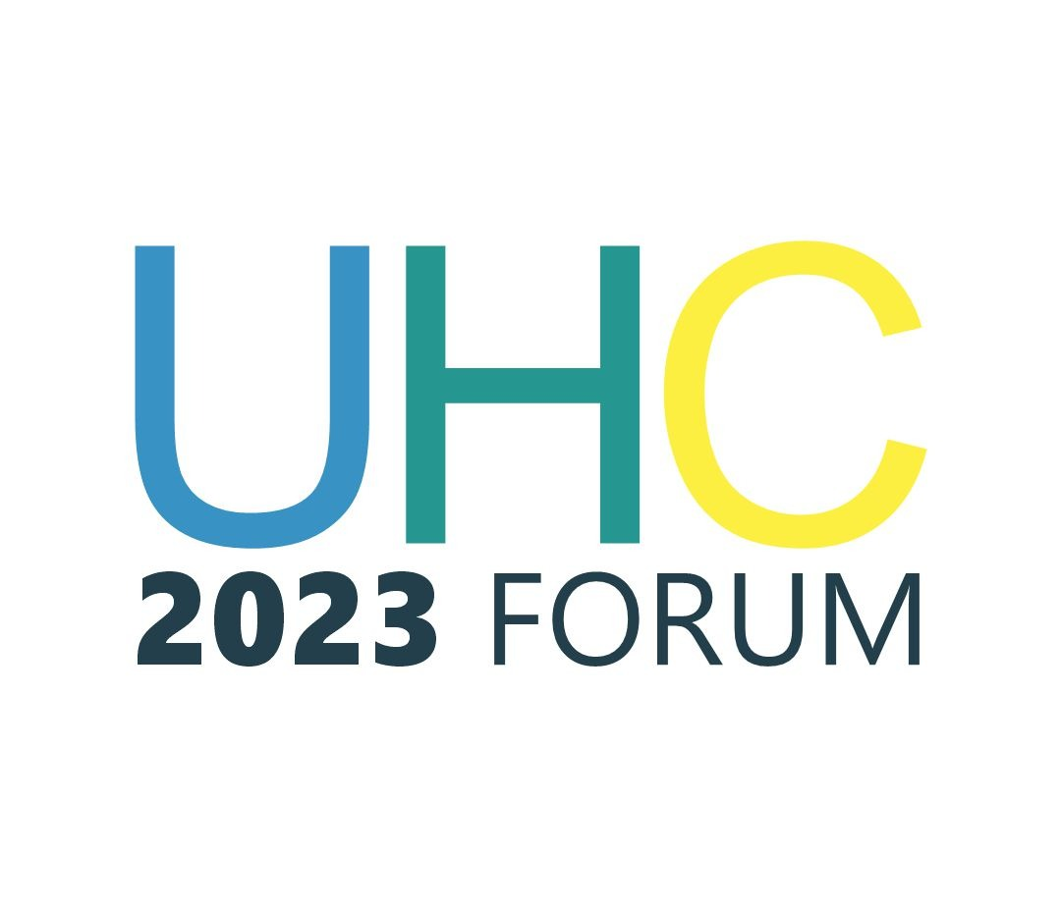
March 03, 2023
HEARTY CONGRATULATIONS TO THE PRESIDENT-ELECT
AND VICE PRESIDENT-ELECT
The Universal Health Coverage (UHC) 2023 Forum heartily congratulates His Excellency Bola Ahmed Tinubu and His Excellency Kashim Shetima, the President-elect and Vice President-elect, respectively, on their victory at the just concluded presidential election. We pray that their ascendance to office ushers in monumental development to Nigeria in general and the health sector in particular.
The UHC 2023 Forum is a coalition of a wide array of stakeholders, including donor agencies, development partners, Civil Society Organizations, and the media, committed to taking advantage of the policy window created by the 2023 general elections to put health on the political front burner towards achieving the UHC goal. The Forum is an assemblage of stakeholders concerned by the sub-optimal health sector performance, which has spurred the platform to articulate a citizen-led health agenda for adaptation by the major political parties in the country.
In line with the objective of placing health on the political agenda of the incoming administration, the UHC 2023 Forum is open to working with stakeholders at both national and sub-national levels, especially during the political transition, to shape the health agenda of the new political dispensation.
We believe that a monumental turnaround in the health sector performance is possible if health is accorded its deserved political priority, and we use this opportunity to call on both the President-elect and the Vice President-elect to see health spending beyond a mere expenditure but an investment that will yield significant and socio-economic development and human capital advancement.
We pray that the God Almighty will grant the new leaders the wisdom and energy to successfully steer the country's affairs to bring unprecedented prosperity, peace, and unity to our great nation.
God bless Nigeria

Signed:
Dr. Gafar Alawode
Co-convener, UHC 2023 Forum

Chief Mrs Moji Makanjuola, MFR
Chair and Co-convener, UHC 2023 Forum

